# Continuous Assessment – 1

## Aromal S Kunnel – 22BAI10288

FCFS

CODE :

def fcfs(n):

  processes = []

  for i in range(n):

    process = {"pid": i + 1, "bt": int(input(f"Enter burst time for process {i + 1}: "))}

    processes.append(process)

  processes[0]["wt"] = 0

  processes[0]["tt"] = processes[0]["bt"] + processes[0]["wt"]

  for i in range(1, n):

    processes[i]["wt"] = processes[i - 1]["tt"]

    processes[i]["tt"] = processes[i]["bt"] + processes[i]["wt"]

  total_wt = sum(process["wt"] for process in processes)

  total_tt = sum(process["tt"] for process in processes)

  avg_wt = total_wt / n

  avg_tt = total_tt / n

  print("\nProcess ID\tBurst Time\tWaiting Time\tTurnaround Time")

  for process in processes:

    print(f"{process['pid']}\t\t{process['bt']}\t\t{process['wt']}\t\t{process['tt']}")

  print(f"\nAverage Waiting Time: {avg_wt}")

  print(f"Average Turnaround Time: {avg_tt}")

n = int(input("Enter the number of processes: "))

fcfs(n)

OUTPUT :

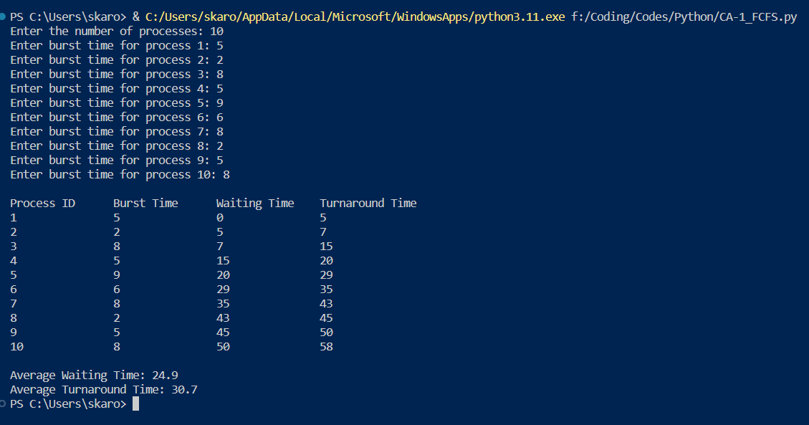

SJF

CODE :

def sjf(processes):

  processes.sort(key=lambda process: process["bt"])

  for i in range(len(processes)):

    if i == 0:

      processes[i]["wt"] = 0

    else:

      processes[i]["wt"] = processes[i - 1]["tt"]

    processes[i]["tt"] = processes[i]["bt"] + processes[i]["wt"]

  total_wt = sum(process["wt"] for process in processes)

  total_tt = sum(process["tt"] for process in processes)

  avg_wt = total_wt / len(processes)

  avg_tt = total_tt / len(processes)

  print("\nProcess ID\tBurst Time\tWaiting Time\tTurnaround Time")

  for process in processes:

    print(f"{process['pid']}\t\t{process['bt']}\t\t{process['wt']}\t\t{process['tt']}")

  print(f"\nAverage Waiting Time: {avg_wt}")

  print(f"Average Turnaround Time: {avg_tt}")

processes = [

    {"pid": 1, "bt": 6},

    {"pid": 2, "bt": 3},

    {"pid": 3, "bt": 8},

    {"pid": 4, "bt": 1},

    {"pid": 5, "bt": 7},

]

sjf(processes)

OUTPUT :

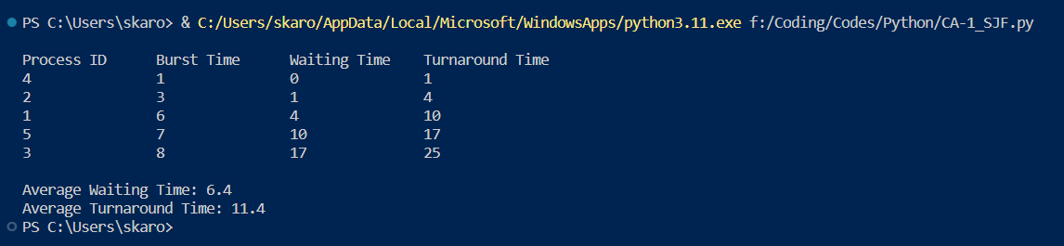

PRIORITY SCHEDULING

CODE :

def priority(processes):

  processes.sort(key=lambda process: process["prior"])

  for i in range(len(processes)):

    if i == 0:

      processes[i]["wt"] = 0

    else:

      processes[i]["wt"] = processes[i - 1]["tt"]

    processes[i]["tt"] = processes[i]["bt"] + processes[i]["wt"]

  total_wt = sum(process["wt"] for process in processes)

  total_tt = sum(process["tt"] for process in processes)

  avg_wt = total_wt / len(processes)

  avg_tt = total_tt / len(processes)

  print("\nProcess ID\tBurst Time\tPriority\tWaiting Time\tTurnaround Time")

  for process in processes:

    print(f"{process['pid']}\t\t{process['bt']}\t\t{process['prior']}\t\t{process['wt']}\t\t{process['tt']}")

  print(f"\nAverage Waiting Time: {avg_wt}")

  print(f"Average Turnaround Time: {avg_tt}")

processes = [

    {"pid": 1, "bt": 6, "prior": 3},

    {"pid": 2, "bt": 3, "prior": 5},

    {"pid": 3, "bt": 8, "prior": 2},

    {"pid": 4, "bt": 1, "prior": 4},

    {"pid": 5, "bt": 7, "prior": 1},

]

priority(processes)

OUTPUT :

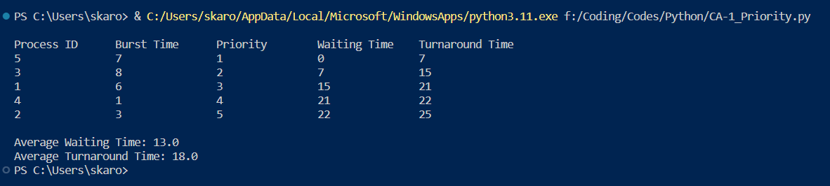

RR

CODE :

def round_robin(processes, time_quantum):

  n = len(processes)

  completed = [False] * n

  waiting_time = [0] * n

  turnaround_time = [0] * n

  current_time = 0

  max_burst_time = max(process["bt"] for process in processes)

  while not all(completed):

    for i in range(n):

      if not completed[i] and processes[i]["bt"] > 0:

        executed = min(processes[i]["bt"], time_quantum)

        # Update process data

        processes[i]["bt"] -= executed

        current_time += executed

        if processes[i]["bt"] == 0:

          completed[i] = True

          turnaround_time[i] = current_time

          waiting_time[i] = turnaround_time[i] - processes[i]["rt"]

      if processes[i]["rt"] <= current_time and not completed[i]:

        processes[i]["rt"] = current_time

  average_waiting_time = sum(waiting_time) / n

  average_turnaround_time = sum(turnaround_time) / n

  print("\nProcess\tBurst Time\tWaiting Time\tTurnaround Time")

  for i in range(n):

    print(f"{i + 1}\t\t{processes[i]['bt']}\t\t{waiting_time[i]}\t\t{turnaround_time[i]}")

  print(f"\nAverage Waiting Time: {average_waiting_time}")

  print(f"Average Turnaround Time: {average_turnaround_time}")

processes = [

    {"bt": 6, "rt": 2},

    {"bt": 3, "rt": 0},

    {"bt": 8, "rt": 1},

    {"bt": 1, "rt": 0},

    {"bt": 7, "rt": 2},

]

time_quantum = 3

round_robin(processes, time_quantum)

OUTPUT :

